**GUI instructions, Employee Module – use cases a,b,g:**

A: Recruiting new employee to a role: (recruit employee, certify employee)

To recruit an employee, run the HRManager window by running the application with the string "GUI HRManager". Click the "Recruit Employee" button, fill in the employee details, and finally click "Submit".

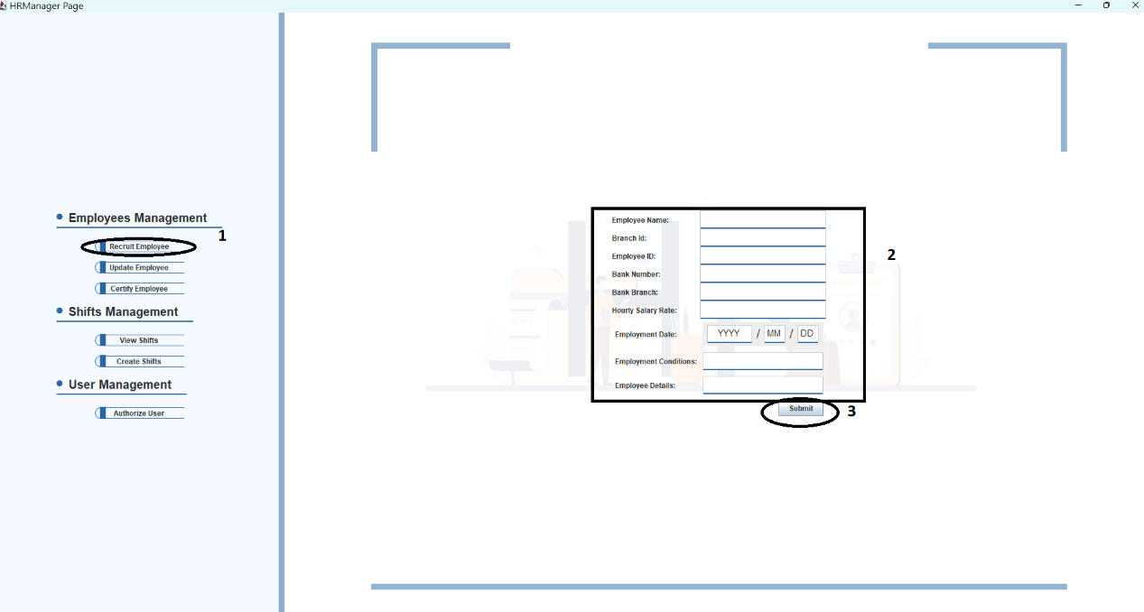

To certify that employee, click the "Certify Employee" button, fill in the employee's Id first and click "Find Employee Roles". Once found, his current certifications appear below. Choose the wanted roles to be certified or uncertified and press certify or uncertify accordingly.

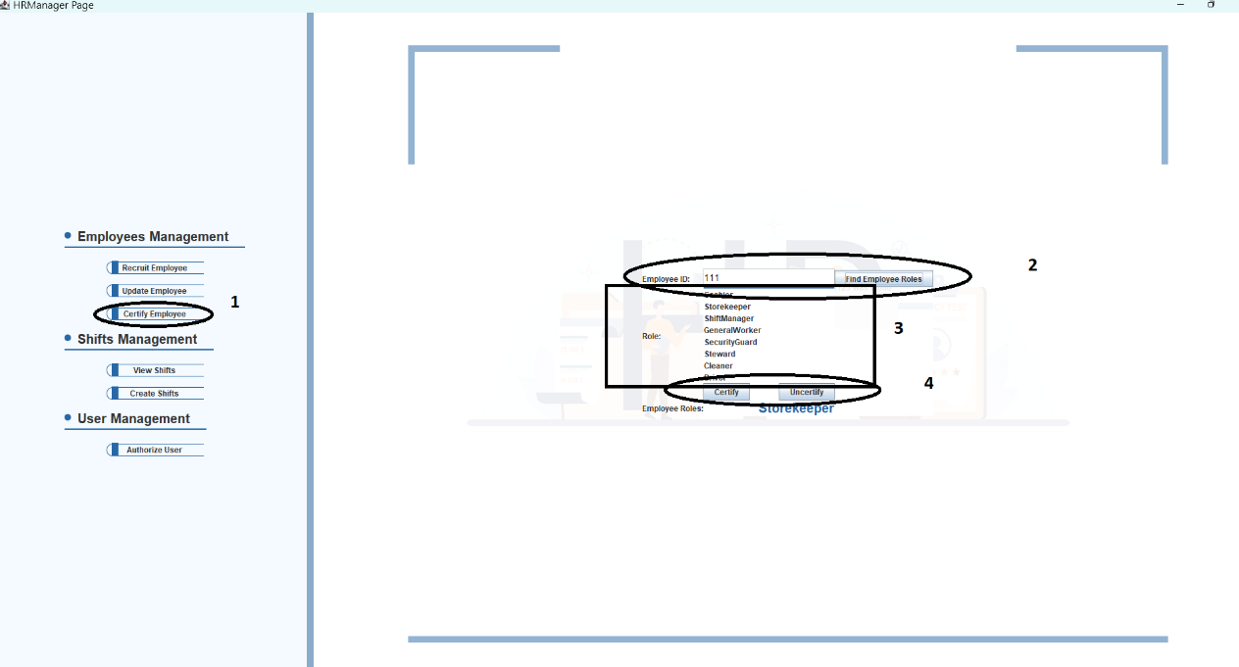

B: Update employee details and availability ( request shift, update details)

To request a shift as an employee, run the employee window with the string: "GUI Employee". Press request shift:

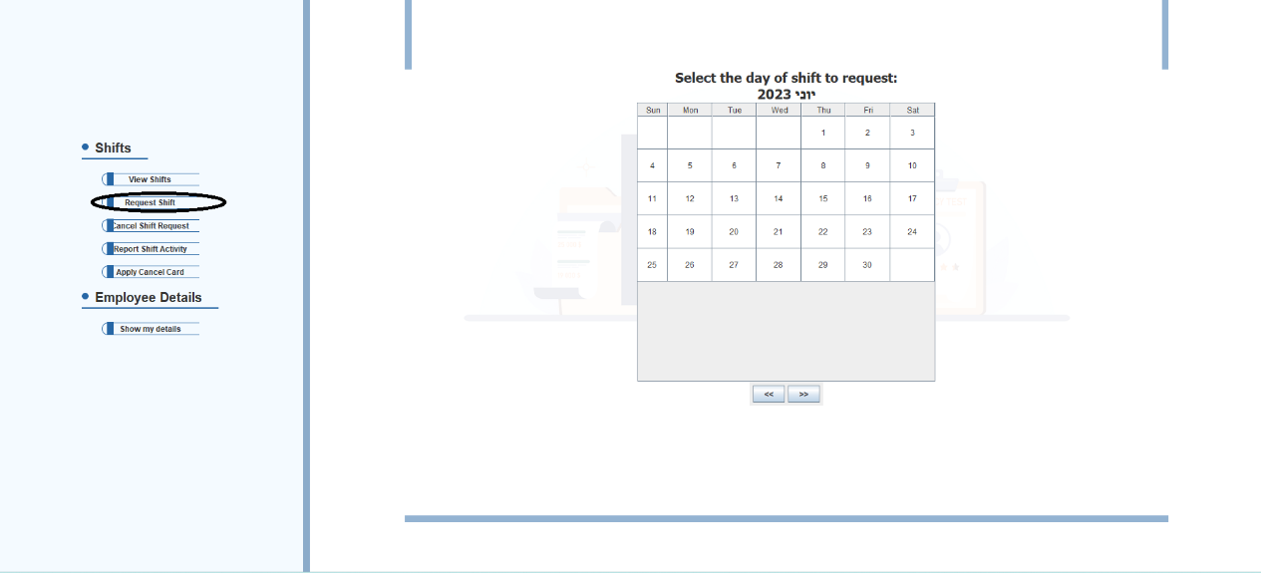

Choose a date (double click):

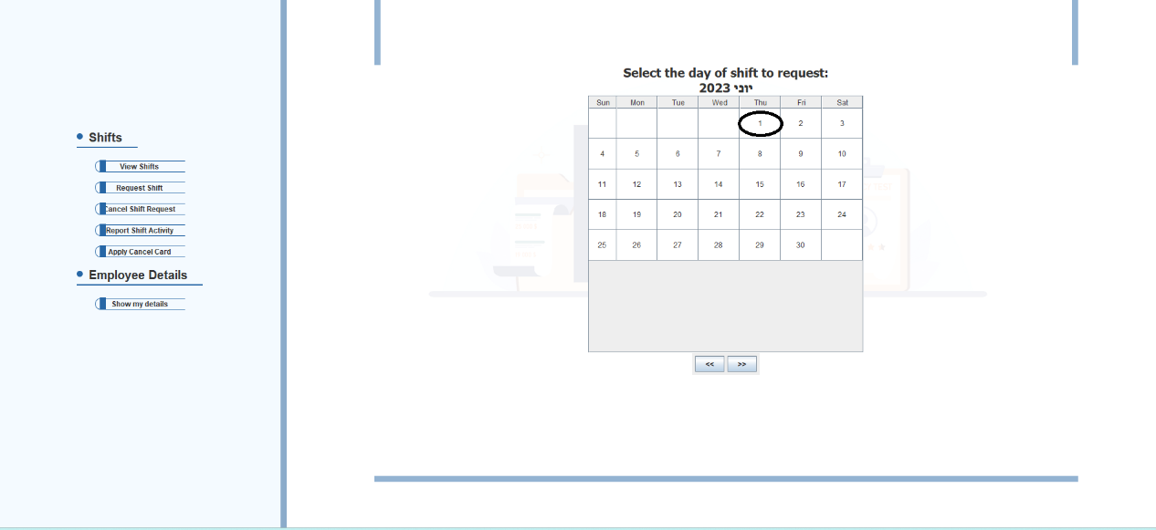

Choose a shift and click "Request Shift":

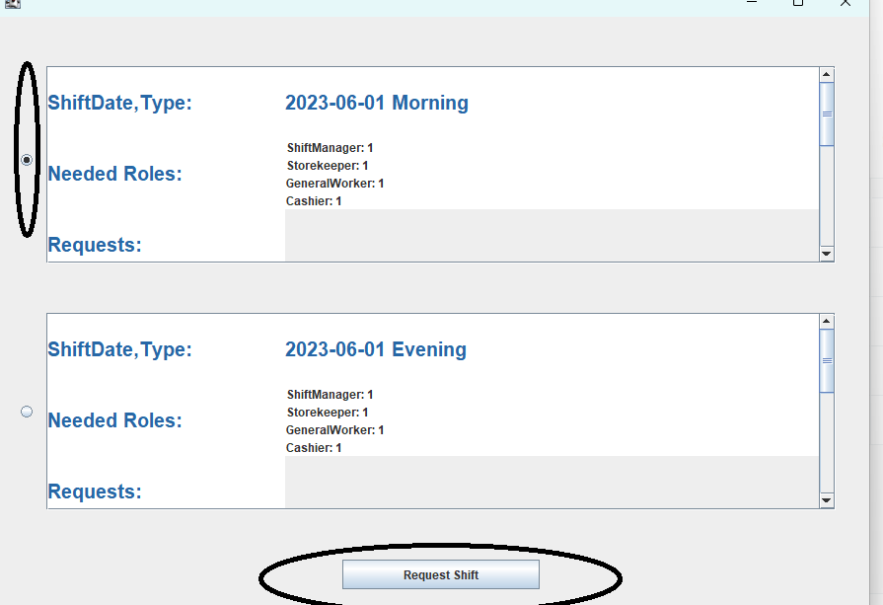

To update Employee details Run the HRManager menu by running the application with the string: "GUI HRManager". Click the "Update Employee" button, fill in the employee ID that is wished to be updated, and click "Find Employee". Once the employee is found, fill in the rest of the employee details as wished to be updated. When finished, press "Submit".

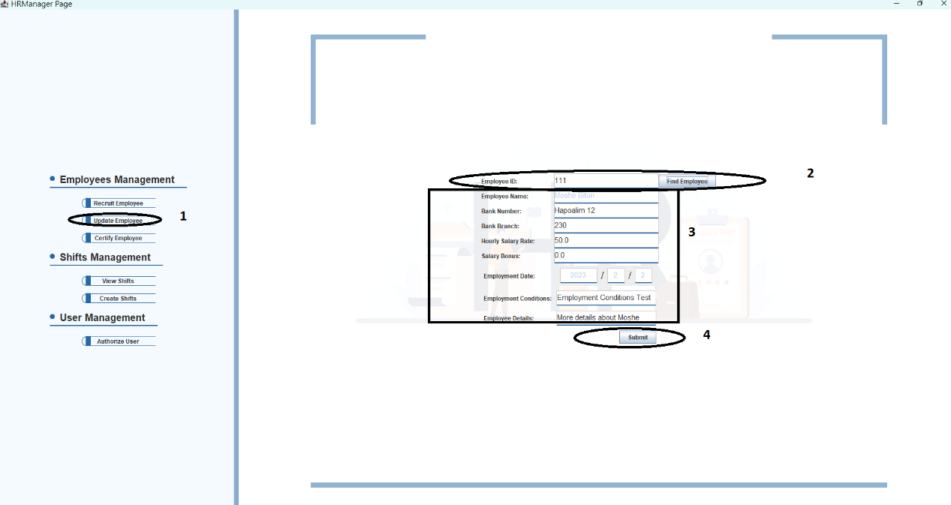

G: Assigining Employees to shifts